Hello and welcome to our Reception class! We are looking forward to getting to know you and your child and are excited about the fun year ahead. These first few weeks are about settling in and getting used to all the new rules and routines. Please see below information and details for this half term. Thank you, Mrs Kelly and Mrs Berry.
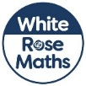  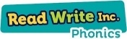  Literacy and Maths  We follow Read Write Inc. phonics to teach your child to read and write.  Your child will:  - Listen to the different sounds they hear.  - Hear and say the initial sounds in words. For example, ‘bat’ begins with b.  - Orally segment (break up) and blend (put back together) some short words e.g. b-a-t.  - Start to read set 1 sounds.  Your child will also be working on both gross motor and fine motor skills .They will explore pre-writing patterns as well as practising to write their name. They will also start to form the set 1 sounds (letters).  Please see some of the texts below that we will be reading in our literacy lessons this half term. We will also be reading some non-fiction texts related to our topic question ‘Why is it marvellous to be me?’  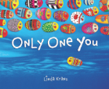  In maths, we follow White Rose Maths which is taught throughout the school.  Your child will:  - Match and sort objects  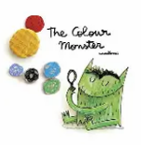  - Compare amounts  - Compare size, mass and capacity  - Explore patterns  Topic  During our topic, your child will explore and talk about themselves, including what makes them special and their likes and dislikes. We will also discuss their emotions, bodies and senses. They will also talk about the world around them including their family, houses, special people and the seasonal changes in our environment. | General Information  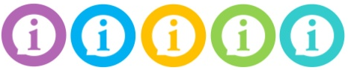  As your child is at the beginning of their school journey, we have lots of information for you! If there is something we haven’t mentioned, please ask. After school is a better time to speak to Mrs Kelly but you can pass on messages in the morning if we need to know at that point.  - Reception Class doors open at 8.40am and school starts at 8.45am. The school day ends at 3.10 pm.  - If someone new is going to be picking your child up, please let us know. Once we have met the person, and you have authorised it, we will not need to check with you again.  - Please can you make sure all items of clothing are clearly labelled.  - If possible, please leave a spare set of clothes on your child’s peg in case they get mucky or have a toileting accident.  - Please bring a pair of wellies to school or leave them on your child’s peg.  - Fruit and milk will be provided every day for your child as well as a school dinner.  - Your child doesn’t need a PE kit.  - Homework will be sent out each Wednesday (starting later in the first half-term) and should be returned to class by Wednesday the following week.  - We will be having a phonics/reading workshop in the next few weeks (date to be confirmed) which will explain how we teach reading in our class and how you can support at home.  - This half term ends on Friday 23rd October.

