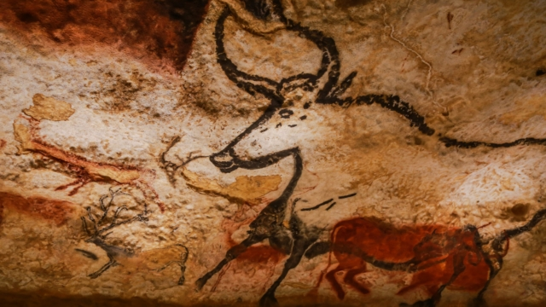
Optional extra task:
-Either make a 3D model of Stonehenge or a model of a tool used in the Stone Age.
Or
Stone Age people built shelters to live in using materials they had gathered. Gather some natural materials and build a model shelter.
Tasks
- Research facts about life in the Stone Age and present your findings as a leaflet. Think about what your sub-headings could be (Food, Homes, Tools, Clothes).
- Draw a piece of cave art using materials of your choice (crayons, paint, chalk. You could even try to use crushed fruit such as berries like real Stone Age people!)
- Write a diary entry from an 8-year-old Stone Age person about a day in their life.
- Find out about the types of homes that Stone Age people lived in. Can you draw and label a Stone Age home showing the materials they were made of?

Stone Age Homework
Children must complete 4 of the tasks above in their homework book. They should only bring their homework book into school on the 9th October or once all tasks have been completed.

