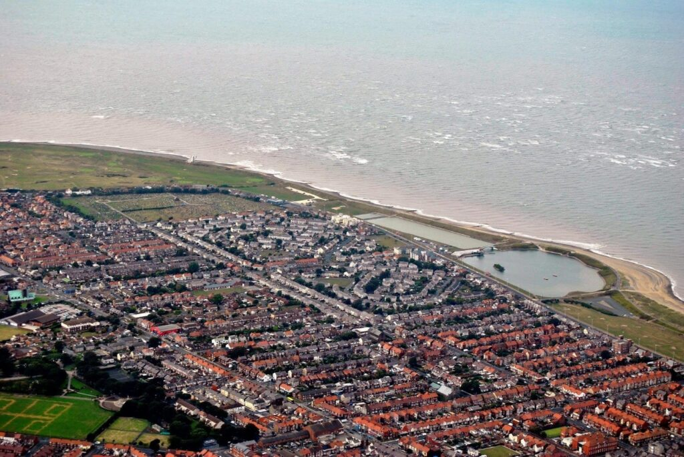
Location Location!
Tasks
- Design a leaflet advertising a seaside town
- Write about the comparison/differences between Rochdale and a seaside town
- Make up your own story set at a seaside location (try to include paragraphs and inverted commas)
- Research 5 facts about a seaside town

Children must complete 4 of the tasks above in their homework book. They should only bring their homework book into school on the 6th July or, once all the tasks have been completed.
Optional extra task:
- Make a model lighthouse
Or
- Make a kite that can fly

