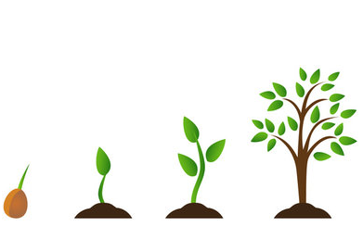
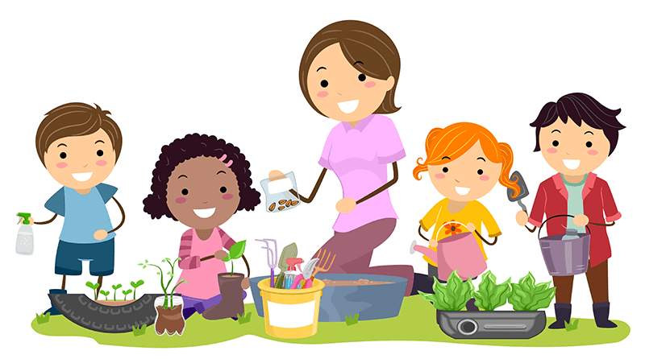
Reception Newsletter
Our topic this half term is
‘Gardeners’ World!’
Hello and welcome back after the Easter break! We are really looking forward to exploring our new topic, ‘Gardeners’ World!’ Please read below for details of what your child will be learning and other information. If you have any questions or would like any further information please speak to Mrs Kelly or Mrs Berry.
    Literacy  Reading and writing will be our big focus this half-term. In class, we will continue with our daily phonics and reading books at your child’s phonic level. We will use carefully selected books to hook the children into our topic, including stories and non-fiction texts. Additionally, we will be asking the children to write more words independently and form sentences using capital letters, finger spaces, correct letter formation and full stops. | 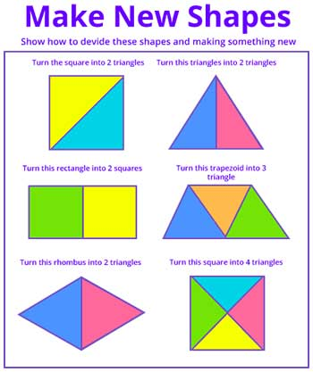  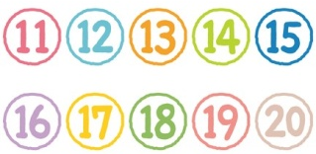  Maths  In maths, we will continue to count on and back, compare, order, subitise and explore ways of making numbers to 10. We will start to add by counting on and take away numbers within 10 and also recall number bonds to 5 and some bonds to 10. We will look at the numbers to 20 and understand them as 10 and another number. Furthermore, we will explore spatial reasoning through matching, manipulating, rotating, combing and separating shapes.
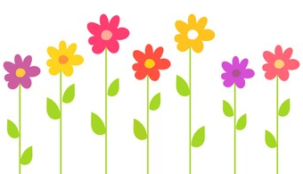  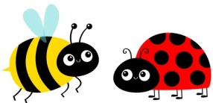  Topic  Our topic this half term is ‘Gardeners’ World!’ We will be exploring the changes that happen in Spring and exploring the natural environment around us. We will be looking at and naming some plants, flowers and trees as well as understanding how they change and grow through planting broad beans. We will look at the plants which we eat and explore ways to keep healthy, including eating a balanced diet. Lots of the children have shown a keen interest in bugs so we will be hunting for minibeasts around our environment, learning their names and finding out where they live. | General Information    - Please can you bring your child’s reading books into school on Mondays and Wednesdays so they can be changed. Please remember to read with your child every day and sign their reading record.  - Please hand in homework on Wednesdays too.  - As the weather is changing, please ensure that your child’s water bottle is in school every day, apply sun cream and send sun hats when it is necessary.  - School will be closed on Bank Holiday - Monday 4th May.  - School closes for half-term on Friday 22rd May and re-opens on Monday 1st June.

