Rochdale Pioneers
Vocabulary |  | Facts |  | Victorians
Mill | A building where raw materials like cotton are made into basic products such as cloth  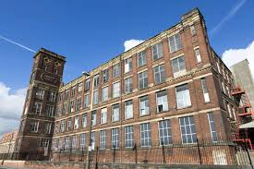 | Industrial revolution | The industrial revolution was a time of change. Products that were often made by hand began to be made by machines in factories and mills  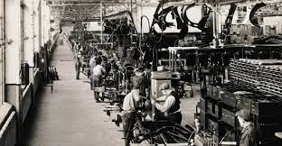 | Queen Victoria | The Last empress from 1837 to 1901. She is one of the longest serving monarchs in British history (63 years). The Victorian era is named after her.  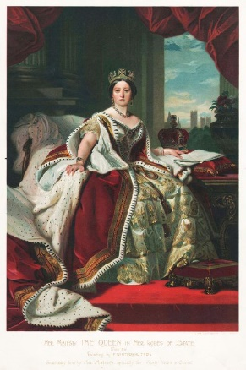
Chimney sweep | A person, often a small child, who would clean chimneys using a long brush. | Weaving | Between 1860 and 1870 Oldham was the most productive cotton-spinning town in the world. By 1911 there were over 200 mills in Rochdale. | Prince Albert | Husband of Queen Victoria, died in 1861.
Reform | Changing something to improve it. | The Pennines | Range of hills and mountains that separate North-West England from Yorkshire. The Pennines have damp air which stopped cotton fibres from snapping | Rochdale Pioneers | 28 men from Rochdale who saved money and started the cooperative movement.
Workhouse | A building where poor people received a bed and food in return for work | Coal mines | Steam engines, locomotives, steamships were fuelled from burning coal. Coal is a rock found underground made from dead plants. | Charles Dickens | Famous Victorian author. He wrote: Oliver Twist, A Christmas Carol and Great Expectations.
Slums | An overcrowded and unpleasant area of a city where poor people live. | 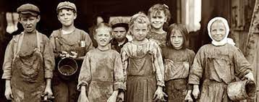  British Empire |  | Dr. Barnardo | Founder of the charity Barnardo’s in 1867 - providing homes and canal A channel of water made by humans for education for poor children.
Reign | The length of time that a person is king or queen for | Empire - A group of countries ruled over by a single king or queen. The British Empire was the largest the world had ever seen. Victoria ruled over the following countries –  India (known as ‘the jewel in the crown’ of the Empire)  Australia  New Zealand  Parts of South America  Parts of Africa including Egypt and Kenya |  | Important Victorian Laws:  1847 Ten Hour Act - No child to work more than ten hours a day  1847 Factory Act - No child to be employed in a factory  1851 Mines Act - No child under ten to work in mines  Rochdale Town Hall  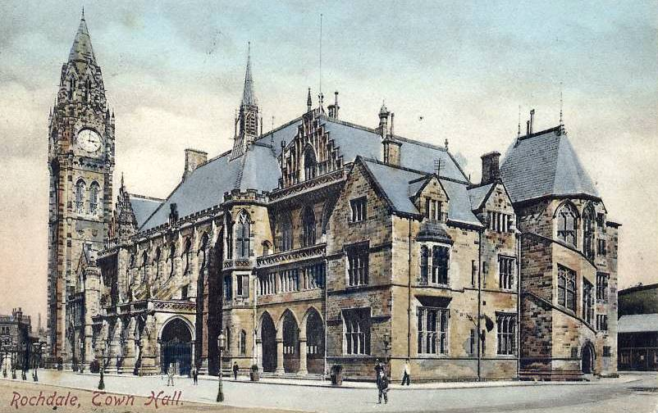
Canal | A channel of water made by humans for education for poor children. travelling by boat or for bringing water to crops or factories | Industrial Revolution
Monarchy | A system of having a king or queen rule over a country. As one king or queen dies, the power is passed to another member of the family. | Characteristics of the Industrial Revolution The five changes that characterised the Industrial Revolution are –  1. The use of new materials such as iron and steel  2. The use of new energy sources such as coal, steam and electricity  3. The invention of machines to increase production  4. Building of large factories  5. Developments in transportation including steam locomotive, cars and planes  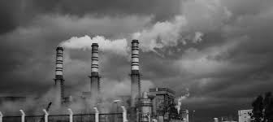
Coal | A hard, black material that is found in the earth and burned as fuel.
Coronation | The special ceremony for crowning a new king or queen.
Cotton | Cotton is a soft fluffy fibre which grows on cotton plants. These were grown in America and imported into Rochdale to make cloth.
Pioneers | Individuals who started or came up with a revolutionary idea.
Cooperative | Everyone working together to achieve a common goal.

